**Objective**

Write a MIPS Assembly program to accept a number N and print the sum of all numbers from 0 to N. The program should display the message "Enter the number of choice" while asking for the input. If the user enters a number less than 0 display an error message: "Error: Number less than or equal to 0!!".

**Assembly Source Codes**

#program to calculate sum of numbers

.data

num : .asciiz "\nEnter the number of your choice:\n" #stored in the global data beacause of the .data

sum : .asciiz "\nThe sum is:\n" #asciiz makes it an string

err : .asciiz "\nError: Number less than or equal to 0!!\n"

.text #Stored in the program section

la $a0,num

li $v0,4

syscall #syscall to print after the li

li $v0,5

syscall

move $s0,$v0 ##s0 has the number

move $s1, $0 # i = 0, counter

move $s2, $0 #initialize sum=0

blt $s1,$s0,end2 #while i!=num

la $a0,err

li $v0,4

syscall

j exit

end2:

#loop to calculate sum until number

loop: #label

add $s2,$s2,$s1 #sum = sum + i

addi $s1,$s1,1 # i=i+1

bgt $s1,$s0,end #while i!=num

j loop

end:

la $a0,sum

li $v0,4

syscall

li $v0,1

move $a0,$s2

syscall

exit:

li $v0,10 #exit program

syscall

**Screen shot of the results**

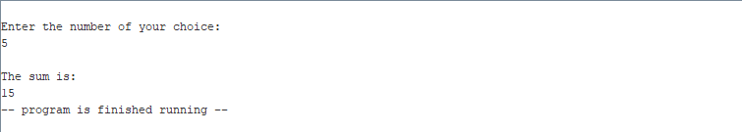

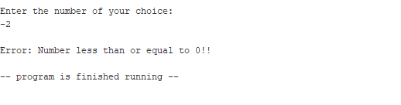

**Conclusion and References**

After adding a branch to ensure that the number is never less than 0, the program works as intended.